**Music Recommendation System for Guitar Learning: A Review and Design of Finger Dexterity Index for Guitar Triad Chords**

**Abstract**

**Music Recommendation Systems (MRS) for Guitar Learning have gained traction and popularity during pandemic times and aids in both self-learning and remote learning. Its research area is of immense importance because of the changed learning and instructing paradigm after COVID-19. Moreover, guitar is one of the toughest instruments to play and growing number of guitar learners, makes system design for guitar learning a very targeted and viable research area. This review paper covers, developments of music recommendation system for guitar learning and guitar playing. This paper proposes a new technique for determining the difficulty of Triad Chords and suggesting easier triad chords that can help a lot of beginner guitarists. The work proposed in the paper is easily comprehensible as it determines the Triad chord difficulty on Likert Scale which proposes 1 as easiest and 5 as difficult.**

**Keywords: Music Recommendation System, Interactive systems, guitar-learning, machine-learning, triad-chords.**

**Introduction**

During the period of Covid-19 Global Pandemic from March 2020 to present day, the paradigm of teaching and learning has shifted drastically. Online and automated teaching methodologies have emerged and evolved in parabolic growth trend. Some of the Teaching or Learning systems employ humans’ interactions complimented with advanced teaching aids like 3-D animations and smart boards. However, some self-paced learning systems are completely automated and they work with user’s input and then predicting the recommendations in learning. These intelligent recommendation systems cater to wide variety of skills such as imaging, photography, painting, web-designing, soft computing, game developments and music. Machine Learning has played an important role in designing state of the art Recommendation Systems for learning a skill or rather more precisely to master a skill. With majority of the students acquiring skills from the internet; the online space is thronged with all sorts of teaching applications for users of all age groups and skill sets.

It is said that music is the food for soul so a good and robust Recommendation System for Music has a daunting task at hand. The task of designing a successful Music Recognition and Recommendation system involves a multi layered series of tasks at different stages, that include music notes analysis and synthesizing them for the recommendation system, audio note representation, models used to analyse these recognition tasks and predicting recommendations based on user input [1][2].

**Music Recommendation Systems for Guitar Learning**

Learning a new musical instrument is a challenging task. Music is a universal phenomenon not bounded by geographies; music learning facilitates people around the globe. Breakthrough systems to assist Indian classical singers [3], system assisting Drum players [4], system assisting music theory learning by understanding music document layout [5], developing datasheets for tablatures of acoustic guitar [6] are utilizing machine learning at their design core. Although music recommendation systems also cater to variety of other applications such as development of software and applications to motivate people for exercising based upon their music preferences [7]. However, guitar being a string instrument features in the list of tough instruments to learn and play. Learning guitar is a multi-faceted activity. The popularity of guitar among musical instruments is paramount. It is however a very difficult instrument for beginners and that is the reason why most beginner guitar learners quit within the first month of learning. The need for learning tools become more important in such cases. Music Recommendation Systems (MRS) developed over the last decade [8], [9], especially focusing on learning guitar have made significant progress. The MRS designed to assist guitar learning span wide aspects of guitar playing. A knowledge repository of MRS devoted to guitar learning suggests that a huge potential of guitar playing aspects can be worked upon. Recommendation systems in the field of audio and music have come a long way and has spanned a much wider variety of applications than anticipated. In this paper, available MRS for aiding Guitar Learning are discussed. All these systems cater to a specific outcome of learning viz, guitar chords, guitar playing techniques, guitar rendition, chord progression etc.

Research in this specific domain can be tracked from earlier system using Augmented Reality (AR) display [10]. The system is helpful in assisting the guitar player by tracking the pose and position of holding the guitar and then presenting a visual guide that may support corrections. The design of support system is an efficient example of using Marker and edge-based tracking in AR for teaching guitars to beginners. Once the guitar player is familiar with holding guitar perfectly, the next stage is to assist the guitar player in chord recognition with greater clarity and decreased level of abstraction. The system in [11] incorporated deep networks consisting of several convolutional layers with Affine layer, 6D-Softmax Layer and Radial Basis Function (RBF) Layer to produce guitar tablature, where the input is music audio and output is human readable chord representation notation that can be widely and easily comprehended by the masses.

Guitar Strumming Teaching system developed in [12], known as strummer is an interactive guitar chord practice system for training musical chords using the data driven approach. The system determines the difficulty of transition from one chord to the other. As there are 180 different types of chords so manually assigning difficulty level for each permutation and combination of transition is not possible. So, linear regression model is applied to find the difficulty of transition which is mapped to difficulty level on 5 – Likert scale (1: easiest and 5: difficult). The work in [13] proposes a novel representation which collaborates VAE (Variational Auto Encoder) with GP (Gaussian Process) subsequently denoted as GP-VAE. Database is classified into seven playing techniques named as: normal, muting, vibrato, pull off, hammer-on, sliding and bending. Each technique has 1000 epochs. Proposed GP-VAE is claimed to be beneficial for a class relevant discriminative task.

An interesting system development illustrated in [14]estimates the guitar string, fret and plucking position. It uses parametric pitch estimation to extract the location where the hands are interacting with the fretboard of guitar and string. The system uses feature set of three parameters and these parameters are estimated with Non-linear Least Squares (NLS) pitch estimators. String model is developed by modelling string displacement, activated by plucking. String is modelled with an initial deflection excited at plucking position by the plucking hand with an edge sharp pick at a fraction of the length. Electrical transducer has been employed to measure displacement. The observed signal is modelled in vector matrix notation. Least square method is used to estimate the amplitudes and the estimated amplitude vector is used to further estimate the plucking position. The proposed method starts with detecting the onset event followed by extraction of one segment. As for plucking position estimation, log spectral (LS) distance is minimized between observation and the model. It uses recorded data at 44.1 KHz which consists of electric and acoustic guitar recordings specific to their string and fret combination. Further classifier is trained on 9360 recordings. Through the obtained confusion matrices, very low error rate is obtained for acoustic guitar while electric guitar shows average error rate of 3% which lies in the range of 1 to 3 percent. Finally plucking position estimation is done on two 12 second recordings of electric guitar.

The chord recognition system proposed in [15] uses a transform domain approach using Discrete Sine Transform (DST). Its aim is to investigate the influence of sampling frequencies which do not follow Shannon sampling theorem. This system proposes the input as an isolated wave format of recorded chord signal. The said chord signals are recorded employing sampling frequencies from 2500 Hz to 78Hz. Normalization of input signal data has been done to correct variation on its maximum absolute value. After normalisation, silence area and transition removal has been done on the left side of the signal data. Various operations such as frame blocking and windowing are performed. Quasi Harmonic Product Spectrum (QHPS) is used for eliminating unwanted harmonic signals. Significant local peak’s appearance is increased by logarithmic scaling. Further ten feature extractions are obtained through a total of ten samples per chord, which are then averaged to obtained a reference feature extraction for each chord. All seven chords are recorded ten times to obtain 70 test chords. It is observed that no influence on recognition rates for values above 95 percent is observed for a sampling frequency range of 2500Hz to 156 Hz. However, lowest sampling frequency of 156 Hz and shortest feature extraction length of 16 points are obtained. Also, it is noticed that sampling frequency below 625Hz do not follow Shannon sampling theorem where Least frame blocking length of 128 points and feature extraction length of 16 points are used.

The Guitar Ontology system in [16], a goal-oriented form of description is employed with a focus on classical guitar. Usage of OWL (Ontology Web Language) has significantly enhanced machine readability and machine processability. It describes an annotation method that integrated data between the ontology and score information. Guitar rendition ontology for teaching and learning support of classical has been developed, action processes are focussed upon to explain the concept which are classified according to purposes related to sound such as timber, articulation, percussion etc. Further properties such as primary action and conditional action have been explored to define the action processes on the basis of which the concepts are explained. Finally, a method is presented that annotates the ontology knowledge onto musical structures. It aims to bridge the gap between humans understanding of rendition knowledge and computer processing in order to build and develop an interactive and knowledge intensive system. The system in [17] determines a correct chord label by observing ‘altered’ notes. The allocated notes are often reduced, increased and changed to other notes in real musical concerts and compositions. As a result of omitting, inversions and tension voicing, the allocation of notes is not the same as the definition of chords. The system aims to provide solution to such discrepancies by constructing and applying a searching tree for chord labels and chord progressions database. Though the estimation accuracy changes with played guitar, which is addressed by investigating the difference in electric guitars. Chroma vectors representing the power of all pitch classes are generated from the sounds of an electric guitar. Further, the chord label is estimated by calculating a logical AND operation between results from the search tree and the chord progression database. Finally, the average chord label estimation accuracy is obtained on each guitar from guitar number 1 to guitar number 4. It suggests the effectiveness of cutting high frequency components in order to reduce the influence of difference in electric guitars. The systems’ average accuracy is around 40%.

Guitar Playing Technique (GPT) classification is yet another interesting area of research that involves various GPTs like normal, muting, vibrato, sliding, hammer-on, pull offs and bending. The system in [18] endeavours to automatically segregate GPTs. Spectral Temporal Receptive Field (STRF) based scale and rate descriptor constructed system identifies GPTs which results in very high recognition rates. It shows improvement as high as 11.47 and 13.32 percent in average F-scores in the baseline and Deep Belief Network (DBN) baseline respectively. GPT classification system results in an average F-score of 80.23 percent with the split signal and 96.82 percent with the complete signal.

In the system presented in [19] , the generation of chord progression from symbolic representation as a prediction problem is formulated. Neural attention mechanism has been incorporated to investigate the overall performance of the system. In order to generate candidate chords from chord progression sequences, an LSTM based neural network is employed, along with a multi modal interface deploying a Kinect device. A total of 560 unique chords are present in the data set presented in Mc-Gill Billboard datasets containing chord sequences of all weekly number 1 billboard hits between 1958-1992. Three different architectures are deployed viz the baseline, the baseline utilizing a switch mechanism and the attention utilizing architecture in the interactive environment using tensorflow framework. The results obtained with the use of Long Short Term Memory (LSTM) based architecture exploiting attention modules are found to be relatively satisfying only with regard to short term prediction ability. It is also observed that the use of neural attention mechanism in the chord generator significantly increased the variety of chords offered.

The summary of all the key points of the above discussed papers is presented below in the tabular form for a clearer comprehension.

**Technologies used in Music Recommendation System (MRS) for Guitar Learning**

Table 1 Overview of Discussed research articles

|  |  |  |  |  |
| --- | --- | --- | --- | --- |
| Reference | Year | Knowledge Acquisition Process/Dataset | Framework/Platform | Task Performed/Expected Output |
| [10] | **2006** | USB camera and a display connected to a PC | **Augmented Reality, Vision Marker model-based tracking** | Guitar Playing (Holding Frets and strings) |
| [11] | **2014** | 475 Music recordings consisting of 181 songs from Christopher Harte’s Beatles dataset*  100 songs from the RWC pop dataset  194 songs from the US pop dataset  200 tracks from Mc-Gill Billboard Data set with 560 unique chords. [20] | **Deep Networks with convolutional layers, AFFINE layers, 6D softmax layer, RBF layer** | Guitar Chord Recognition (Representation Learning) |
| [12] | **2017** | Mc-Gill Billboard Data set with 560 unique chords.[20] using context-free transition representation.[21] | **Akaike Information Criterion (AIC) Model Optimization** | Guitar Strumming |
| [13] | **2018** | Sound Clips in GPT Database (GPT Dataset from the work of Su-et-al[22] | **Gaussian Process Variational Auto Encoder (GP-VAE)** | Guitar Playing Techniques (GPT) |
| [14] | **2019** | Guitar Recordings of electric and acoustic guitar, electric LesPaul Firebrand with Elixir Nanoweb (.10-.54) strings and an acoustic Martin DR with SP(.12-.52) strings. | **Non-Linear Least Square (NLS) Inharmonic Pitch Estimation** | Guitar string, fret and plucking position. |
| [15] | **2019** | Chords Signals recorded from Yamaha CPX-500-II in wave format | **DST based Segment Averaging** | Guitar Chord Recognition |
| [16] | **2019** | Declarative and Procedural Knowledge using Protégé | **Web Ontology Language (OWL)** | Guitar Renditions |
| [17] | **2019** | Chord Progression Database /Search Trees using Pitch Class Profiles (PCPs) or Chroma Vectors | **Chord Label Estimation Method Using Comb Filter** | Guitar Chord Labels |
| [18] | **2020** | Sound Clips in GPT Database (GPT Dataset from the work of Su-et-al [22] | **Hierarchical Cascaded Deep Belief Network/Spectral Temporal Receptive Fields (STRF)** | Guitar Playing Techniques (GPT) |
| [19] | **2020** | Mc-Gill Billboard Dataset with 560 unique chords. [20] | **LSTM based Neural Network** | Guitar Chord Progression |

**Proposed Music Recommendation System for Guitar Triad Chords**

A complete system essentially consists of various key components. However, to limit the complexity and scope of discussion, these are classified into two key components:

1. Music information retrieval and recognition at the initial stage [23].
2. Music data processing, prediction and recommendation at the final stage.

The recommendation systems reviewed in this paper do not calculate the difficulty of chord playing depending upon the position of the chord. It has motivated us to propose a system that can calculate the difficulty of chord triads and suggest easier chords. Guitar chords have many variations like open chords, barre chords, power chords and Triads. Out of these Triads are the simplest with only 3 notes to be played in a chord. A chord is a group of notes played simultaneously rather than sequentially, like a melody. A scale is a pattern made out of notes using whole and half steps. There are 7 notes (musical alphabets) present in guitar viz, C-D-E-F-G- A-B-. The distance or spacing is uneven which is known as musical distance. This distance is filled by some other notes (known as sharp notes) and the resulting uniform distance scale looks like this pattern

C - C# - D - D# - E – F – F # - G - G# - A – A # - B - C

A scale can be constructed for each note. For example, to construct major scale for A, the pattern will start from A and selects notes after A at a distance of steps mentioned in theory of major scale. So, the A major scale becomes the following pattern

A – B – C # - D – E – F# - G# - A

There are several types of triad chords depending on the different intervals between the notes. A chord triad consists of 3 notes. The construction of chord begins with the selection of a root note. Now A major triad chord is formed by selecting only 3 notes from this scale. Those notes are A, the root note followed by 3rd note and 5th note. So, A Major Triad chord consists of A, C# and E notes.

Triads have 4 variations:

* Major Triad (constructed using Root note- major3rd note and perfect 5th note)
* Minor Triad (constructed using Root note- minor3rd note and perfect 5th note)
* Diminished Triad (constructed using Root note- minor 3rd note and diminished 5th note)
* Augmented Triad (constructed using Root note -major 3rd note and augmented 5th note).

Each triad further has 3 positional variations:

* Root position – (the root note is the bass note followed by 3rd and 5th note)
* 1st inversion (the 3rd note is the bass note followed 5th note and root note)
* 2nd inversion (the 5th note is the bass note followed by root note and the 3rd note).

Furthermore, they can be played with bass on 6th, 5th 4th or 3rd string which makes it confusing in terms of number of choices we get to play a particular chord. For example, A major triad can be played in 12 different ways or positions all over the fretboard. Now determining the best fit position of a chord in a specific form of guitar playing style is purely subjective and depends upon person’s skill level and finger dexterity level. So, the training set of all these possible chord positions need to be prepared so as to analyse the difficulty level of same chord at different positions. This needs to be done extensively for all possible chords for their Triads.

Here at this conjecture, a deterministic index named as “Finger Dexterity Index” is proposed which aims at providing the user with a more convenient numerical value assigned to the difficulty of playing a chord. As discussed already it is subjective to define the difficulty level of the chord playing as it depends on various factors like barring the fret, positions of notes on the fret, distance of notes on the fret, age of the guitar player, arm and finger strength of the guitar player etc. At the initial phase of designing the proposed Intelligent Triad Finger Dexterity Index for Cadence and chord progression recommendation, we can incorporate only a few widely agreeable weighted difficulty parameters as in this case two parameters that are considered are fret positions and string positions; that would define the difficulty level of chords with an assigned numeral value. The entire system is proposed to be built on Neural Networks with reinforcement learning on multiple training input variables yielding a single numerical value depicting difficulty at the output.

Figure 1 shows the weights of fret positions governed by fret difficulty index. It is computed for 15 frets normalized with respect to 15th fret and an increase of 5 percent difficulty increase as we move up the fretboard with each fret increment. The sum of weights of notes used on the frets for a triad are calculated as A in the table. The separation distance I can also be computed from this index.

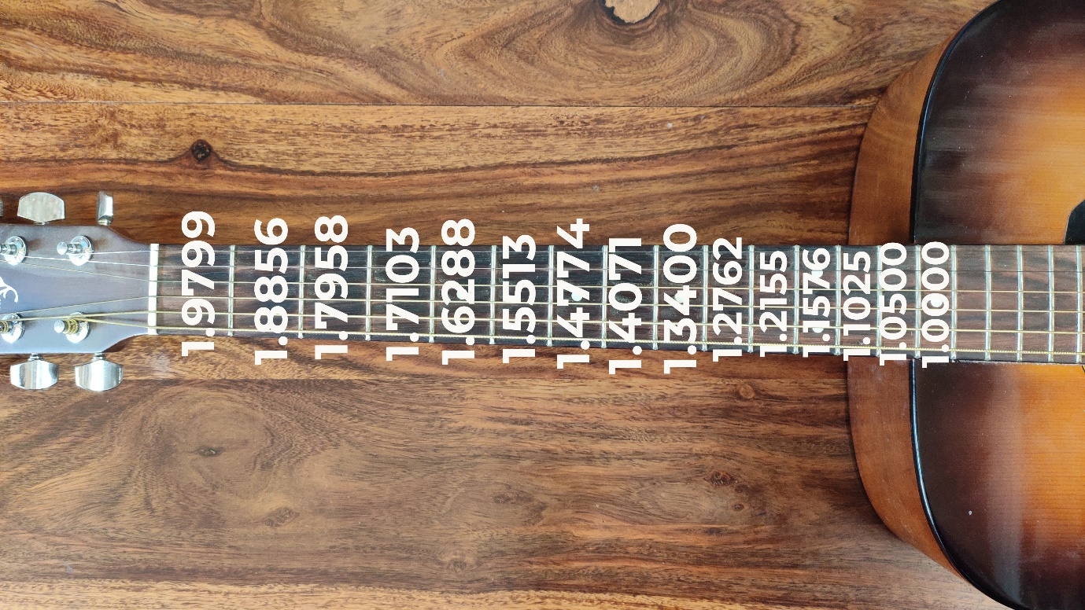

Figure-1: Fret Difficulty Index

Secondly the string difficulty index is normalized with respect to high e string as 1 and 10 percent increase in the strings as we go from e-B -G-D-A-E (the thickest string). This is used to calculate B in the Table-1 depending upon which strings are pressed for the chords.

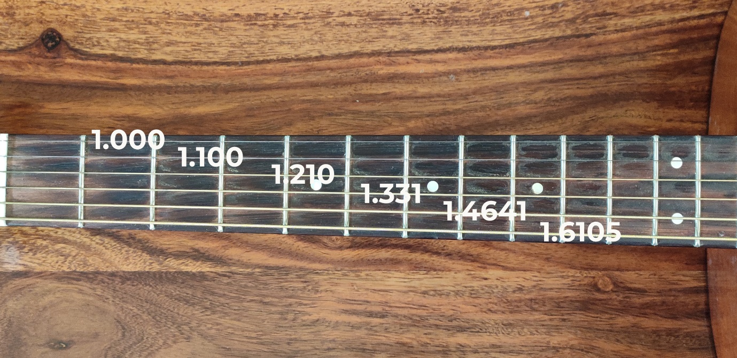

Figure 2: String Difficulty Index

Table 2 Proposed Finger Dexterity Index

|  |  |  |  |  |  |  |  |  |  |  |  |  |
| --- | --- | --- | --- | --- | --- | --- | --- | --- | --- | --- | --- | --- |
| SCALE-A | | | | | | FINGER DEXTERITY INDEX CALCULATOR | | | | | | |
| TRIAD TYPE | MAJOR |  | POSITION | 1ST INVERSION | |
| MINOR |  |
| DIMINISHED | ü |
| AUGUMENTED |  |
| BASS NOTE | BASS STRING | STRING | FRET | NOTE | FREQ | SUM OF WEIGHTS OF FRET POSITIONS=A | WEIGHT OF MAXIMUM NOTE SEPARATION (DISTANCE OF FRETS) =I | SUM OF WEIGHTS OF STRINGS POSITION=B | WEIGHT OF MAXIMUM NOTES SEPARATION (DISTANCE OF FRETS) =I | A*I=AI | B*I=BI | FINGER DEXTERITY INDEX = AI+BI |
| C | 6 | 6 | 8 | C | 131 | 4.4358 | 0.1442 | 4.4056 | 0.1442 | 0.6396 | 0.6352 | 1.2748 |
| 5 | 6 | D# | 156 |
| 4 | 7 | A | 220 |
| C | 5 | 5 | 3 | C | 131 | 5.6613 | 0.1841 | 4.0051 | 0.1841 | 1.0422 | 0.7373 | 1.7795 |
| 4 | 1 | D# | 156 |
| 3 | 2 | A | 220 |
| C | 4 | 4 | 10 | C | 262 | 3.9595 | 0.1309 | 3.641 | 0.1309 | 0.5182 | 0.4766 | 0.9948 |
| 3 | 8 | D# | 311 |
| 2 | 10 | A | 440 |
| C | 3 | 3 | 5 | C | 262 | 4.9679 | 0.0815 | 3.31 | 0.0815 | 0.404 | 0.2697 | 0.6737 |
| 2 | 4 | D# | 311 |
| 1 | 5 | A | 440 |

Built on top of the finger dexterity index, this paper proposes a system which could provide users with some suggestive chord progressions and cadences which are ought to be by far the easiest to play depending upon the input key or scale that user wants to play.

**Conclusions**

The MRS for guitar teaching and learning have come a long way and yet there is tremendous scope of development for systems that can aid various aspects of the guitar playing. The system proposed in this paper will help in retention of beginner players. This system has a lot of scope of scalability and future improvisations as it just aims at triad chords. Further research and enhancements can be made in system developments that uses seventh chords and power chords There is vast scope of system development and implementation in the area of cadence suggestions and recommendation.

**References**

[1] H. Purwins, B. Li, T. Virtanen, J. Schlüter, S. Y. Chang, and T. Sainath, “Deep Learning for Audio Signal Processing,” *IEEE J. Sel. Top. Signal Process.*, vol. 13, no. 2, pp. 206–219, 2019, doi: 10.1109/JSTSP.2019.2908700.

[2] M. Schedl, “Deep Learning in Music Recommendation Systems,” *Front. Appl. Math. Stat.*, vol. 5, no. August, pp. 1–9, 2019, doi: 10.3389/fams.2019.00044.

[3] A. Bagavathi, S. Krishnan, S. Subrahmanyan, and S. L. Narasimhan, “RagamAI: A network based recommender system to arrange a Indian classical music concert,” *Proc. - 18th IEEE Int. Conf. Mach. Learn. Appl. ICMLA 2019*, pp. 1517–1522, 2019, doi: 10.1109/ICMLA.2019.00250.

[4] C. Laroche, M. Kowalski, H. Papadopoulos, and G. Richard, “Hybrid Projective Nonnegative Matrix Factorization with Drum Dictionaries for Harmonic/Percussive Source Separation,” *IEEE/ACM Trans. Audio Speech Lang. Process.*, vol. 26, no. 9, pp. 1499–1511, 2018, doi: 10.1109/TASLP.2018.2830116.

[5] J. Calvo-Zaragoza, K. Zhang, Z. Saleh, G. Vigliensoni, and I. Fujinaga, “Music Document Layout Analysis through Machine Learning and Human Feedback,” *Proc. Int. Conf. Doc. Anal. Recognition, ICDAR*, vol. 2, pp. 23–24, 2018, doi: 10.1109/ICDAR.2017.259.

[6] S. J. Joysingh, P. Vijayalakshmi, and T. Nagarajan, “Development of Large Annotated Music Datasets using HMM based Forced Viterbi Alignment,” *IEEE Reg. 10 Annu. Int. Conf. Proceedings/TENCON*, vol. 2019-Octob, pp. 1298–1302, 2019, doi: 10.1109/TENCON.2019.8929664.

[7] J. Fang, D. Grunberg, S. Lui, and Y. Wang, “Development of a music recommendation system for motivating exercise,” *Proc. 2017 Int. Conf. Orange Technol. ICOT 2017*, vol. 2018-Janua, pp. 83–86, 2018, doi: 10.1109/ICOT.2017.8336094.

[8] A. Patel and R. Wadhvani, “A Comparative Study of Music Recommendation Systems,” *2018 IEEE Int. Students’ Conf. Electr. Electron. Comput. Sci. SCEECS 2018*, pp. 1–4, 2018, doi: 10.1109/SCEECS.2018.8546852.

[9] P. Du, X. Li, and Y. Gao, “Dynamic Music emotion recognition based on CNN-BiLSTM,” *Proc. 2020 IEEE 5th Inf. Technol. Mechatronics Eng. Conf. ITOEC 2020*, no. Itoec, pp. 1372–1376, 2020, doi: 10.1109/ITOEC49072.2020.9141729.

[10] Y. Motokawa and H. Saito, “Support system for guitar playing using augmented reality display,” *Proc. - ISMAR 2006 Fifth IEEE ACM Int. Symp. Mix. Augment. Real.*, pp. 243–244, 2006, doi: 10.1109/ISMAR.2006.297825.

[11] E. J. Humphrey and J. P. Bello, “From music audio to chord tablature: Teaching deep convolutional networks toplay guitar,” *ICASSP, IEEE Int. Conf. Acoust. Speech Signal Process. - Proc.*, pp. 6974–6978, 2014, doi: 10.1109/ICASSP.2014.6854952.

[12] I. I. Conference, “STRUMMER : AN INTERACTIVE GUITAR CHORD PRACTICE SYSTEM Intelligent Systems Laboratory , The University of Tokyo 2 National Institute of Advanced Industrial Science and Technology ( AIST ) 1 Interactive,” no. July, pp. 1057–1062, 2017.

[13] S. H. Chen, Y. S. Lee, M. C. Hsieh, and J. C. Wang, “Playing Technique Classification Based on Deep Collaborative Learning of Variational Auto-Encoder and Gaussian Process,” *Proc. - IEEE Int. Conf. Multimed. Expo*, vol. 2018-July, pp. 1–6, 2018, doi: 10.1109/ICME.2018.8486467.

[14] “ESTIMATION OF GUITAR STRING , FRET AND PLUCKING POSITION USING PARAMETRIC PITCH ESTIMATION Jacob Møller Hjerrild and Mads Græsbøll Christensen Audio Analysis Lab , CREATE , Aalborg University , Denmark,” pp. 151–155, 2019.

[15] L. Sumarno, “The Influence of Sampling Frequency on Guitar Chord Recognition using DST Based Segment Averaging,” *Proceeding - 2019 Int. Conf. Artif. Intell. Inf. Technol. ICAIIT 2019*, pp. 65–69, 2019, doi: 10.1109/ICAIIT.2019.8834628.

[16] N. Iino, S. Nishimura, T. Nishimura, K. Fukuda, and H. Takeda, “The Guitar Rendition Ontology for Teaching and Learning Support,” *Proc. - 13th IEEE Int. Conf. Semant. Comput. ICSC 2019*, pp. 404–411, 2019, doi: 10.1109/ICOSC.2019.8665532.

[17] N. Yasui, M. Miura, and T. Shimamura, “Chord Label Estimation from Acoustic Signal Considering Difference in Electric Guitars,” *Proc. - 2019 Int. Symp. Intell. Signal Process. Commun. Syst. ISPACS 2019*, no. 2, pp. 31–32, 2019, doi: 10.1109/ISPACS48206.2019.8986390.

[18] C.-Y. Wang *et al.*, “Spectral-Temporal Receptive Field-Based Descriptors and Hierarchical Cascade Deep Belief Network for Guitar Playing Technique Classification,” *IEEE Trans. Cybern.*, pp. 1–12, 2020, doi: 10.1109/tcyb.2020.3014207.

[19] C. Garoufis, A. Zlatintsi, and P. Maragos, “AN LSTM-BASED DYNAMIC CHORD PROGRESSION GENERATION SYSTEM FOR INTERACTIVE MUSIC PERFORMANCE School of ECE , National Technical University of Athens , Zografou 15773 , Greece Robot Perception and Interaction Unit , Athena Research Center , 15125 Maroussi ,” *ICASSP 2020 - 2020 IEEE Int. Conf. Acoust. Speech Signal Process.*, pp. 4497–4501, 2020.

[20] J. A. Burgoyne, J. Wild, and I. Fujinaga, “An expert ground-truth set for audio chord recognition and music analysis,” *Proc. 12th Int. Soc. Music Inf. Retr. Conf. ISMIR 2011*, no. Ismir, pp. 633–638, 2011.

[21] C. Harte, M. Sandler, S. Abdallah, and E. Gómez, “Symbolic representation of musical chords: A proposed syntax for text annotations,” *ISMIR 2005 - 6th Int. Conf. Music Inf. Retr.*, pp. 66–71, 2005.

[22] L. Su, L. F. Yu, and Y. H. Yang, “Sparse cepstral and phase codes for guitar playing technique classification,” *Proc. 15th Int. Soc. Music Inf. Retr. Conf. ISMIR 2014*, no. Ismir, pp. 9–14, 2014.

[23] B. Rathnayake, K. M. K. Weerakoon, G. M. R. I. Godaliyadda, and M. P. B. Ekanayake, “Toward Finding Optimal Source Dictionaries for Single Channel Music Source Separation Using Nonnegative Matrix Factorization,” *Proc. 2018 IEEE Symp. Ser. Comput. Intell. SSCI 2018*, pp. 1493–1500, 2019, doi: 10.1109/SSCI.2018.8628941.